ROC’D
Rapid Online Course Development Project

Assessment Book

Checklists and Assessment Questions
For the Time Management Instructional Module:
Creating an Assignment
Creating and Assessment
Creating an Electronic Calendar

Use this book along with the instructional module.

Designed by:
Erin Gunter
Kevin Wicker
Assessment Items
Pre-Test (Assessment tools for Entry Behaviors):

1. Do you know how to login to a Blackboard LMS account?
____ Y or ____ N

2. What are the qualities of a good assignment?
A.
B.
C.
D.

3. What are the qualities of a good assessment?

4. What is an open-ended item?

5. What is a multiple choice item?

6. What is a matching item?

7. What is a true/false item?
Assessment Checklists and Questions that Accompany the
Creating an Assignment Video

  - Demonstrate how to access the assignment page
___ Log on the Blackboard Account
___ Access the Course
___ Make sure you are in the build tab
___ Locate the course tools navigation bar
___ Click on the Assignment link
1.1.1 Find the assignment tab by placing a checkmark close to the tab.
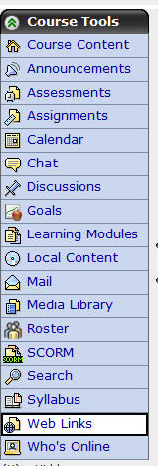

  - Click on the create assignment link within the instructional video.

    - Classify the following components into whether or not they are good components for an online assignment.
Timeline
Description
Multiple Ways to complete the assignment
Title
Unlimited submissions

  - Demonstrate entering an assignment to access the assignment page
___ Identify a title in the title box
___ Identify a description in the description box
___ Identify a timeline for the assignment using the date and time boxes

    - Identify title – Circle the title box in the following screen shot and write the title “Module One” in the title box.
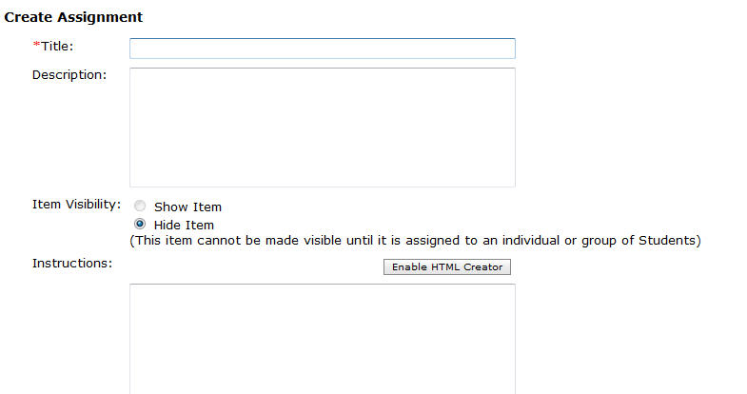
    - Identify description – Circle the description box in the following screen shot and write the description “Reading and Summary Assignment” in the description box.
    - Identify timeline – Circle the due date box and due date time box in the following screen shot and write the following due date and due date time “12/10/2008” and “12:00 PM” in the appropriate boxes.
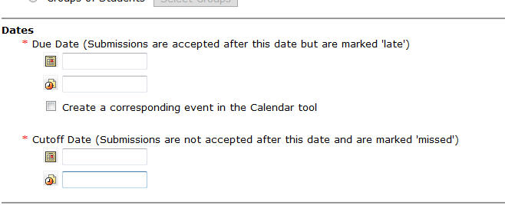

  - Click on the save button at the bottom of the page within the instructional video.

Assessment Checklists and Questions that Accompany the
Creating an Assessment Video

  - Demonstrate how to access the assessment page
___ Log on the Blackboard Account
___ Access the Course
___ Make sure you are in the build tab
___ Locate the course tools navigation bar
___ Click on the Assessment link

2.1.1 Find the assessment tab by placing a checkmark close to the tab.

  - Click on the create assessment link within the instructional video.

    - Identify title – Circle the title box in the following screen shot and write the title “Module 4” in the title box.
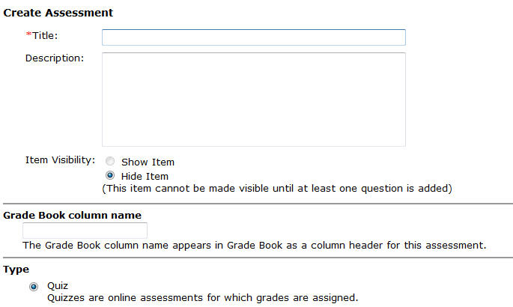

    - Identify description – Circle the description box in the following screen shot and write the description “A four-item assessment.” in the description box.
    - Identify timeline – Circle the due date box and due date time box in the following screen shot and write the following due date and due date time “12/10/2008” and “5:00 PM” in the appropriate boxes.

Circle the cutoff date box and cutoff date time box in the following screen shot and write the following cutoff date and cutoff date time “12/12/2008” and “5:00 PM” in the appropriate boxes.

  - Click on the save and add questions button at the bottom of the page within the instructional video.

    - Click on the create question button within the instructional video.

      - Demonstrate creating a matching item using the quiz tool
___ Click on the matching link in the drop down menu
___ Fill in the title
___ Fill in the matching statements
___ Fill in the matching answers
___ Save the matching item

      - Demonstrate creating a multiple choice item using the quiz tool
___ Click on the multiple choice link in the drop down menu
___ Fill in the title
___ Fill in the multiple choice question
___ Fill in the multiple choice answers
___ Select the correct multiple choice answer
___ Save the multiple choice item

      - Demonstrate creating an open-ended item using the quiz tool
___ Click on the short answer link in the drop down menu
___ Fill in the title
___ Fill in the open-ended question
___ Fill in the open-ended answer
___ Save the open-ended item

      - Demonstrate creating a true/false item using the quiz tool
___ Click on the true/false link in the drop down menu
___ Fill in the title
___ Fill in the true/false statement
___ Fill in the whether the statement is true or false
___ Save the true/false item

  - Demonstrate how to save an assessment in the assessment page
___ Finish creating all the questions
___ Save all the questions
___ Select show assessment in assessment page

Assessment Checklists and Questions that Accompany the
Creating an Electronic Calendar

  - Demonstrate how to access the electronic calendar page
___ Log on the Blackboard Account
___ Access the Course
___ Make sure you are in the build tab
___ Locate the course tools navigation bar
___ Click on the Calendar link

3.1.1 Find the calendar tab by placing a checkmark close to the tab.

  - Click on the add entry link within the instructional video.

Assessment Checklists and Questions that Accompany the
Creating an Assignment Entry in the Electronic Calendar

      - Click on the add entry button within the instructional video.

        - Identify title – Circle the title box in the following screen shot and write the title “Module 3 Team Activity” in the title box.
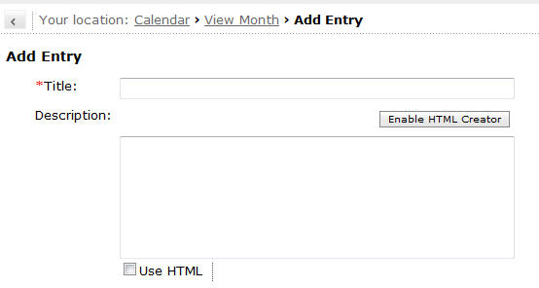
      - Schedule an assignment due date on the electronic calendar.
___ Identify the start date
___ Identify the end date
___ Identify course with public access entry type

        - Identify Start Date for assignment calendar entry - Circle the start date box and the start date time box and write the following start date and start date time in the appropriate boxes, “12/4/2008”and “12:00 PM” for the assignment.
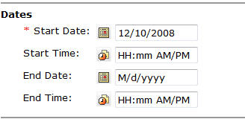
        - Identify End Date for assignment calendar entry - Circle the end date box and the start end time box and write the following end date and end date time in the appropriate boxes, “12/10/2008”and “11:59 PM” for the assignment.

        - Identify course with public access entry type - Circling the course and public entry types.
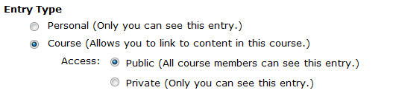

      - Demonstrate creating a hyperlink between the calendar entry and the assignment in the assignment page.
___ Click on More Options
___ Click on the Add Content Link
___ Select Assignments
___ Select the Assignment “Module 3 Team Activity”
___ Click Add Selected

      - Click on the save button within the instructional video.

Assessment Checklists and Questions that Accompany the
Creating an Assessment Entry in the Electronic Calendar

      - Click on the add entry button within the instructional video.

        - Identify title – Circle the title box in the following screen shot and write the title “Module 3 Quiz” in the title box.
      - Schedule an assignment due date on the electronic calendar.
___ Identify the start date
___ Identify the end date
___ Identify course with public access entry type

        - Identify Start Date for assessment calendar entry - Circle the start date box and the start date time box and write the following start date and start date time in the appropriate boxes, “12/3/2008”and “8:00 PM” for the assessment.
        - Identify End Date for assessment calendar entry - Circle the end date box and the start end time box and write the following end date and end date time in the appropriate boxes, “12/4/2008”and “8:00 PM” for the assessment.

        - Identify course with public access entry type - Circling the course and public entry types.

      - Demonstrate creating a hyperlink between the calendar entry and the assignment in the assignment page.
___ Click on More Options
___ Click on the Add Content Link
___ Select Assessments
___ Select the Assessment “Module 3 Quiz”
___ Click Add Selected

      - Click on the save button within the instructional video.
Final Assessment (Post-Assessment of the Terminal Objective)

At this point you should have completed the instructional module and all the assessments for each of the videos. Your task at this time is to create an assignment, and assessment, and an electronic calendar using your Blackboard Vista LMS account using the following checklist below to track your progress.

Create an assignment using a LMS with information from a pre-existing assignment that you have developed.

___ Demonstrate how to access the assignment page in a LMS
___ Identify the Assignment tab in a LMS
___ Demonstrate how to create an assignment
___ Classify a good assignment
___ Demonstrate entering an assignment to the assignment page in a LMS
___ Identify the title
___ Identify the description
___ Identify a timeline
___ Demonstrate how to save an assignment to assignment page in a LMS

Create an assessment using a LMS with information from a pre-existing assessment.

___ Demonstrate how to access the assessment page in a LMS
___ Identify the assessment tab in a LMS
___ Demonstrate how to create an assessment
___ Identify a title for the assessment
___ Identify a description for the assessment
___ Identify a timeline for the assessment
___ Demonstrate entering an assessment to the assessment page in a LMS
___ Create a four-item assessment
___ Demonstrate creating a matching item using the quiz tool
___ Demonstrate creating a multiple choice item using the quiz tool
___ Demonstrate creating an open-ended item using the quiz tool
___ Demonstrate creating a true/false item using the quiz tool
___ Demonstrate how to save an assessment to the assessment page in a LMS

Create an electronic calendar using a LMS.

___ Demonstrate how to access the electronic calendar page in a LMS
___ Identify the calendar tab in a LMS
___ Demonstrate how to schedule an event on the electronic calendar
___ Demonstrate how to schedule an assignment in the electronic calendar
___ Demonstrate entering the assignment event to the electronic calendar
___ Identify a title for the event
___Demonstrate how to schedule the assignment due date
___ Identify start date for the calendar entry
___ Identify end date for the calendar entry
___ Identify course with public access entry type
___ Demonstrate how to link a calendar event to the assignment
___ Demonstrate how to save the calendar event
___ Demonstrate how to schedule an assessment in the electronic calendar
___ Demonstrate entering the assessment event to the electronic calendar
___ Identify a title for the event
___Demonstrate how to schedule the assessment due date
___ Identify start date for the calendar entry
___ Identify end date for the calendar entry
___ Identify course with public access entry type
___ Demonstrate how to link a calendar event to the assessment
___ Demonstrate how to save the calendar event

